**Artificial Intelligence**

**Fall 2017**

**Project #1 Write Up**

The project implements an intelligent agent for Othello. The program was built in Java under Eclipse Mars 4.5.0 environment. To ensure color coding of the board, one would have to go to “Windows” -> “Preferences” -> “ANSI Console” and check “Standard VGA colors” in Eclipse. If that does not work, you might have to select “Help” -> “Install New Software …” and click “Add…” to add the following URL: <https://www.mihai-nita.net/eclipse>. Although I did this, I believe only the former is necessary for color coding. The program allows user to load boards, decide which player goes first, and whether humans or computers would play the game. Below is a sample run of the program. I believe that the program should run without any problem since I have included the entire project as a zip file.

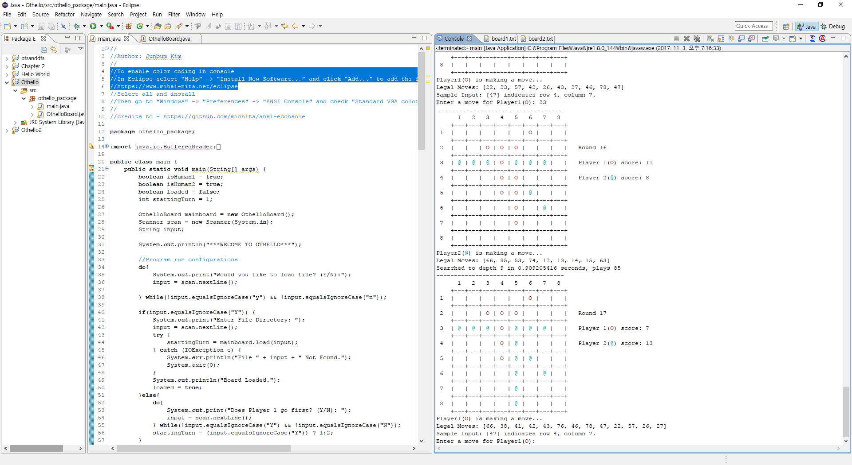

The core algorithm behind the project implements alpha beta pruning along with an iterative deepening search. This allows the program to efficiently search for good moves. The search was designed to stop deepening if it was the it was near time limit. The AI was also designed to go with the move if it has only one legal move. The heuristic function used in the search considers how many corners and edges it has captured, how many pieces it has, and how many moves it has compared to the minimizer. Also, the heuristic was designed to focus on corners in the early game and on pieces in the late game. There are two java classes in the project: main and OthelloBoard. The main class reads in settings for the game and deals with the flow control of the game. The OthelloBoard class holds information about the current state of the board, and serves as a node for the gaming tree. It also holds the heuristic function and depth limited alphabeta search, which is implemented as an iterative deepening search in the main function.

I think that is all I should describe about the project, and I hope you enjoy playing the game!